
T124: ICT272 Web Design and Development Tutorial 5

Topic: ASP.NET MVC Controller Submission: Submit to Moodle link (Week5) Exercise 1 – Answer the following questions:
- Explain the role of Controller in MVC?
- In simple terms, the Controller in MVC is like the manager of the app. When you do something on a website—like click a button or fill out a form, the Controller is the part that notices and says, “Okay, let me figure out what to do.” It talks to the part of the app that handles the data (the Model), gets the info it needs or makes updates, and then decides what page (the View) to show you next. So, it basically keeps things running smoothly between what you do, the data behind the scenes, and what you see on the screen.

- What is the use of Controller class and how it works?
- The Controller class in MVC is like the app's decision-maker. It handles everything that happens when a user interacts with the application, like clicking a button or filling out a form. When a request comes in, the Controller decides what needs to be done, whether it’s getting data from the database (Model) or performing some logic. Once the processing is done, it picks the right page (View) to show the user and sends the result back. In short, the Controller makes sure the right things happen behind the scenes and ensures the user gets the right information displayed on the screen.

- Explain default Controller in MVC?
- The default controller in MVC is the one that takes charge when no specific controller is mentioned in the URL. It’s like a backup controller that gets called when the user just visits the base URL or leaves out some details in the request. For example, if you go to the home page of a website (like http://localhost/), the default controller (often something like HomeController) and its default action (like Index) will automatically handle the request. This setup ensures that there’s always a clear starting point for the application, making it easier to navigate without needing to specify everything in the URL.

Exercise 2: Create ASP.NET MVC application
- Start your visual studio 2019
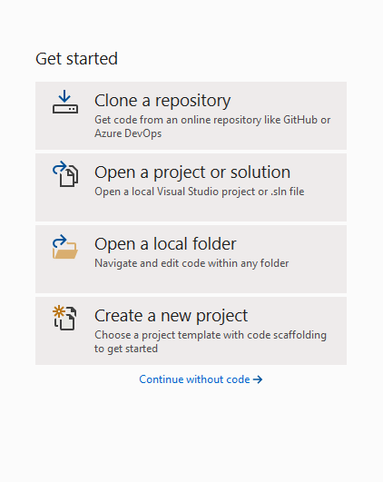
- Click on Create a new project
- Search for “Web Application” in search box and select “ASP.NET Web Application (.NET Framework)” with C# and then click Next.


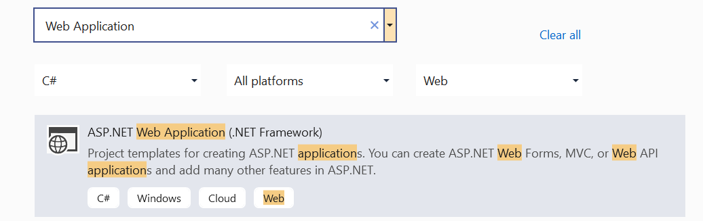
- Name your project “Tutorial6Ex2” and untick “Place solution and project in the same directory”. Then click Create.
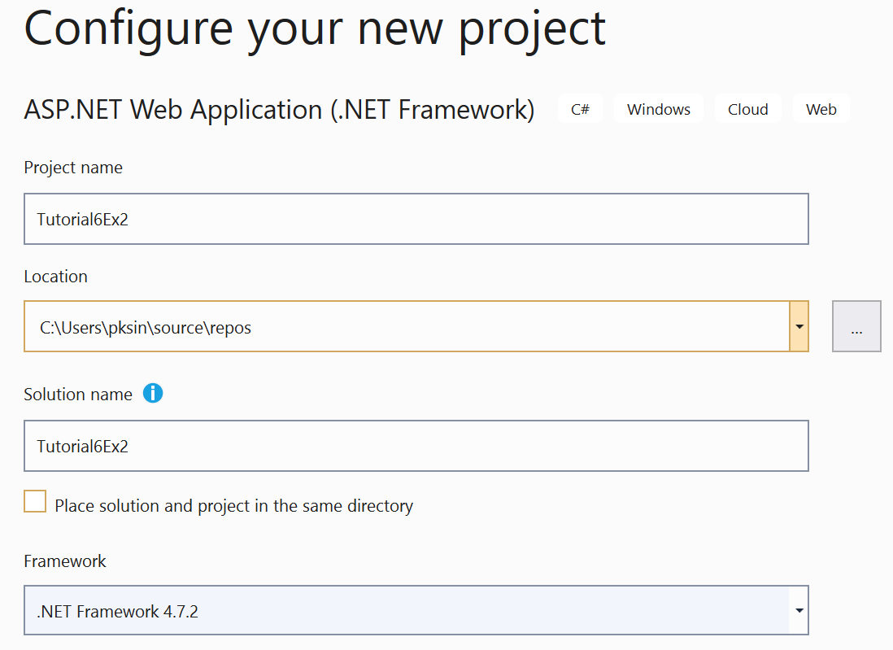
- Choose MVC and then click Create.

Create Controller:
  - Similarly to add a Controller called SubjectController, right-click on Controllers folder, click on Add and select the Controller, In Add New Scaffolded Item Window box, select MVC5 Controller - Empty and click on Add, give the Controller name as SubjectController and click on Add, with this a new controller called SubjectController is added to Controllers folder.


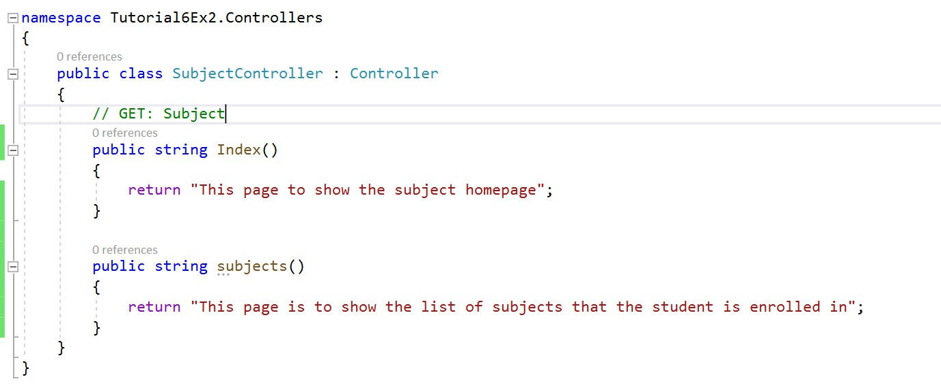
  - Browsing to /Subject/Index leads to execute the code written in the Index method of the SubjectController. This will display following page.
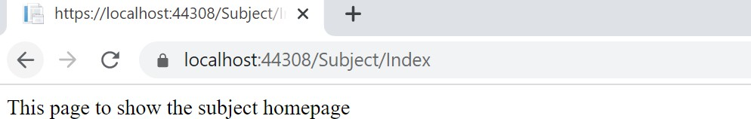

  - Browsing to /Subject/subjects leads to execute the code written in the subjects method of the SubjectController. This will display following page.
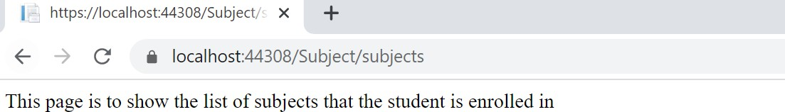

- Actions with Parameters:
  - Add an action with parameter in above created SubjectController.
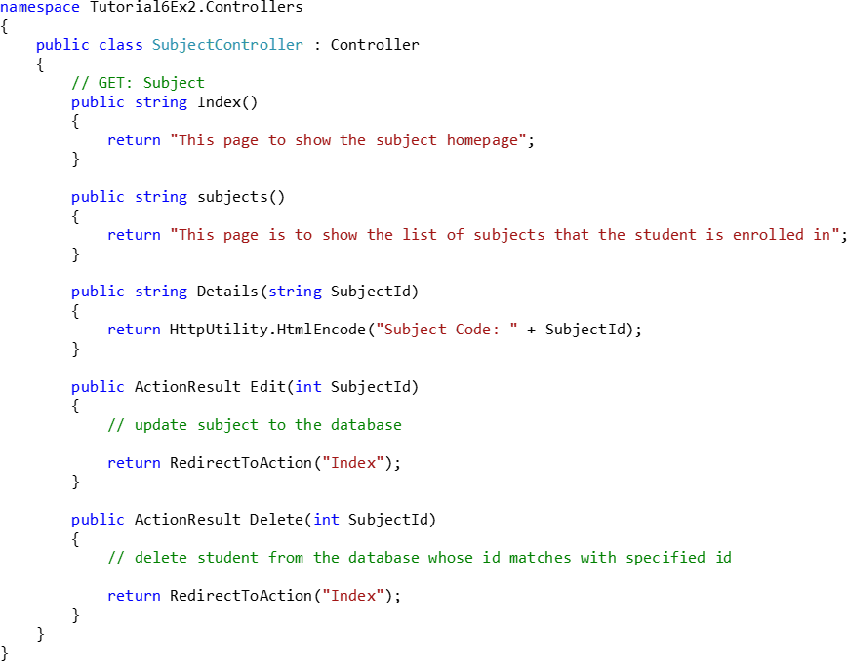


  - Browsing to /Subject/Details with parameter leads to execute the code written in the Details method of the SubjectController. This will display following page.
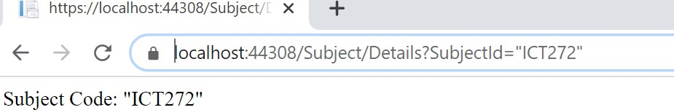

What to submit:
- The source code of Program file (Main function)
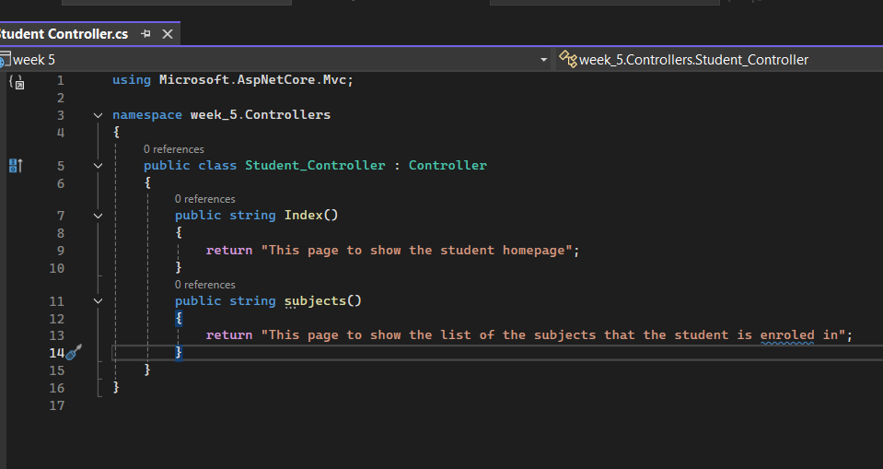

- The output of the program
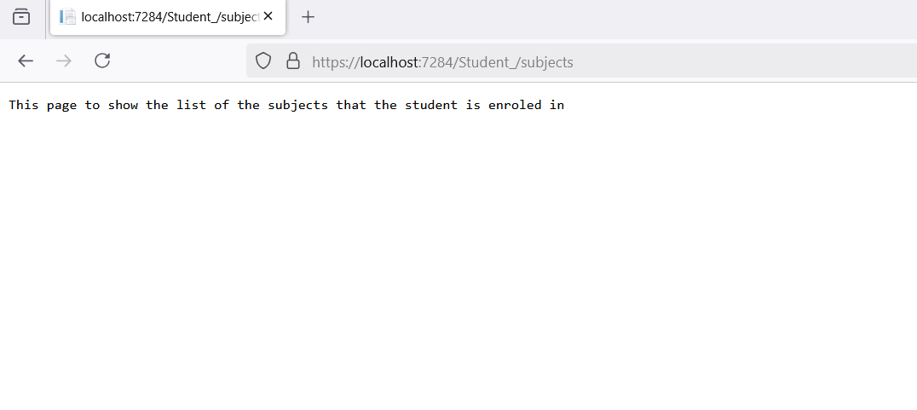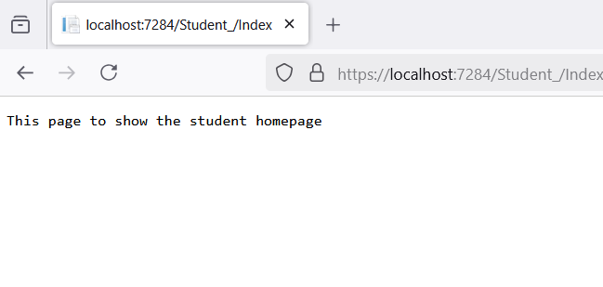

Exercise 3:
- Make the Student as the default controller in Exercise 2
- Create a CampusController and add two methods to show the an overview about the campus and the locations of our campuses

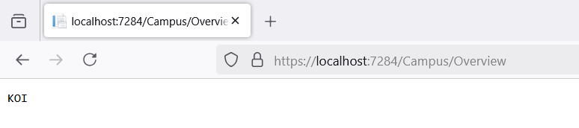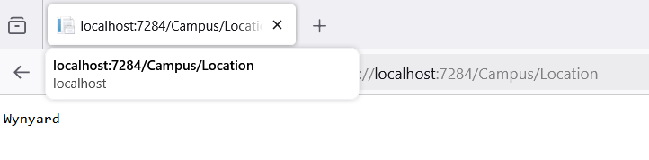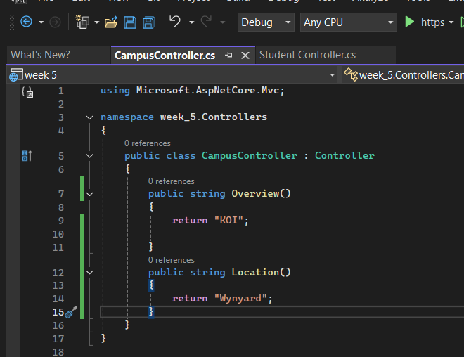
END of Tutorial

